**IT_CASE 1: For creating connection between server and client, translate language**

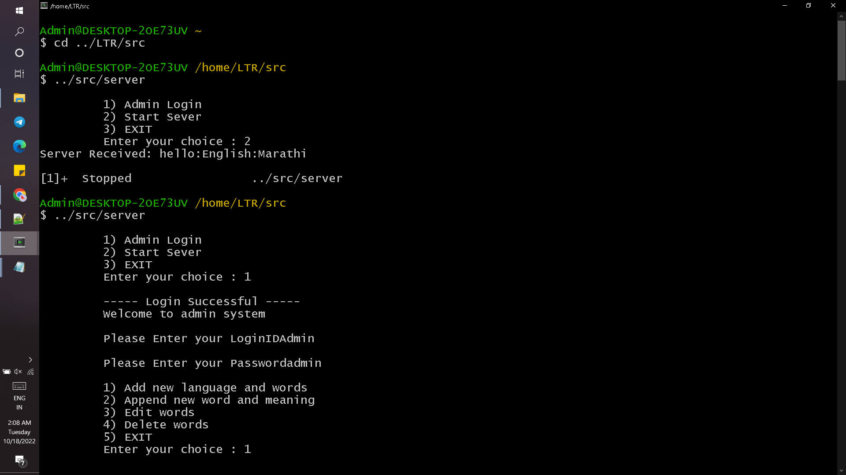

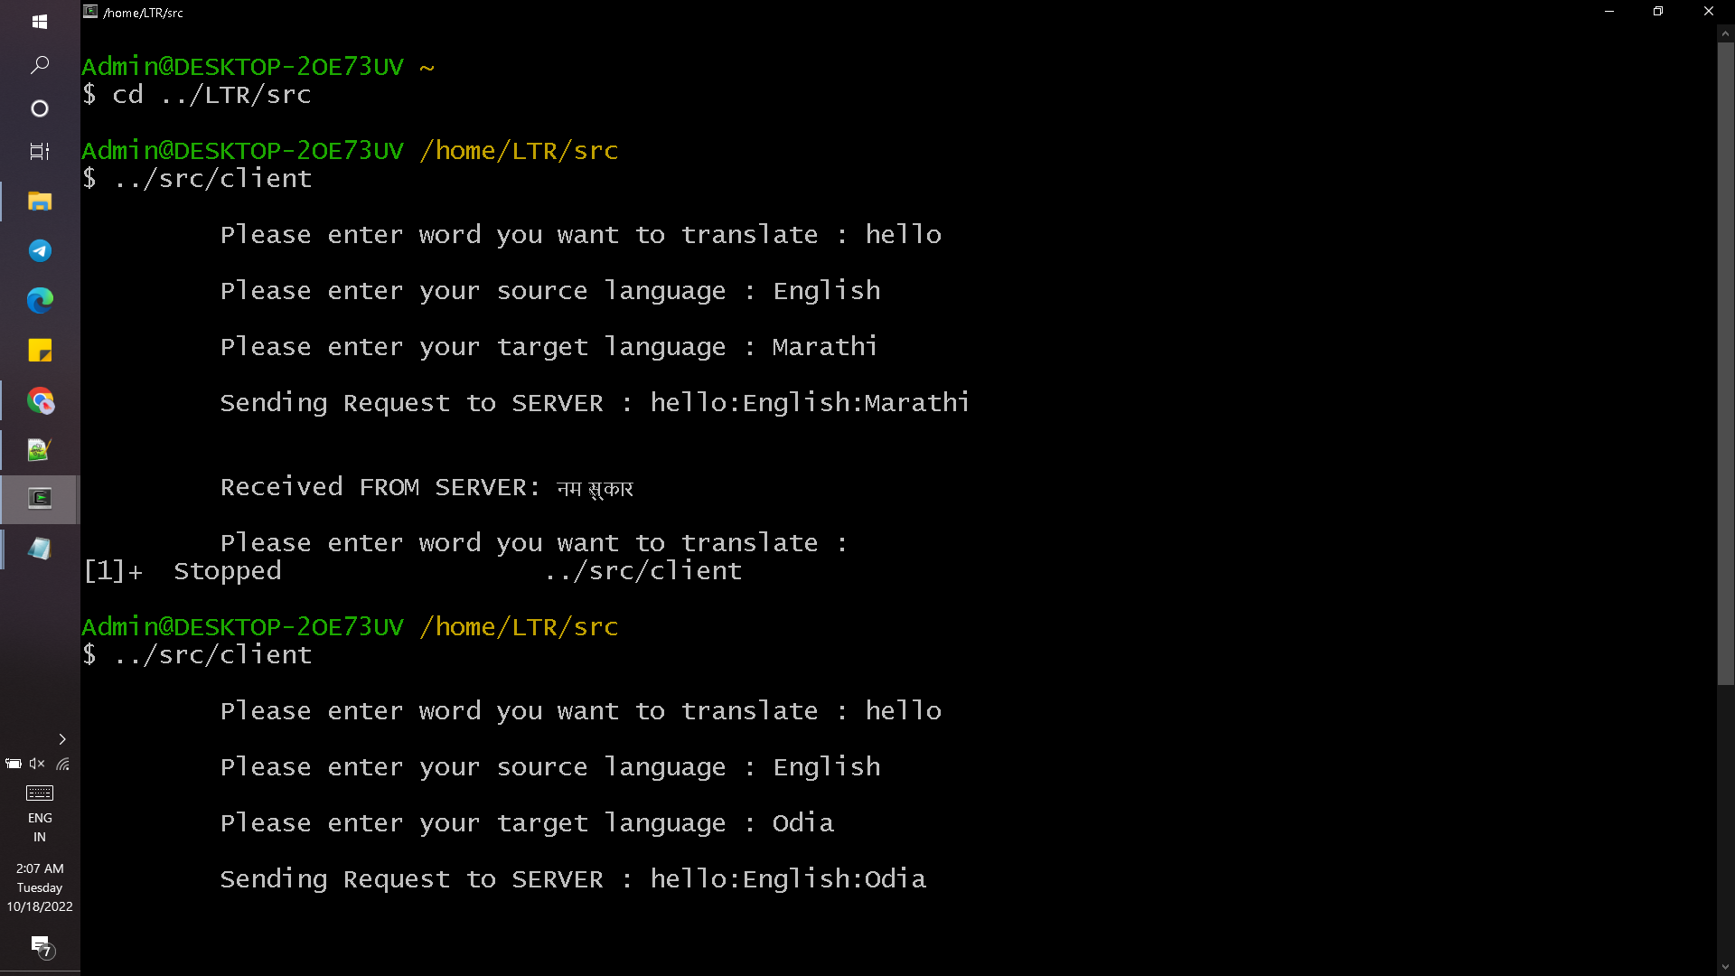

**IT_CASE 2 : Add new language and append new words, meaning**

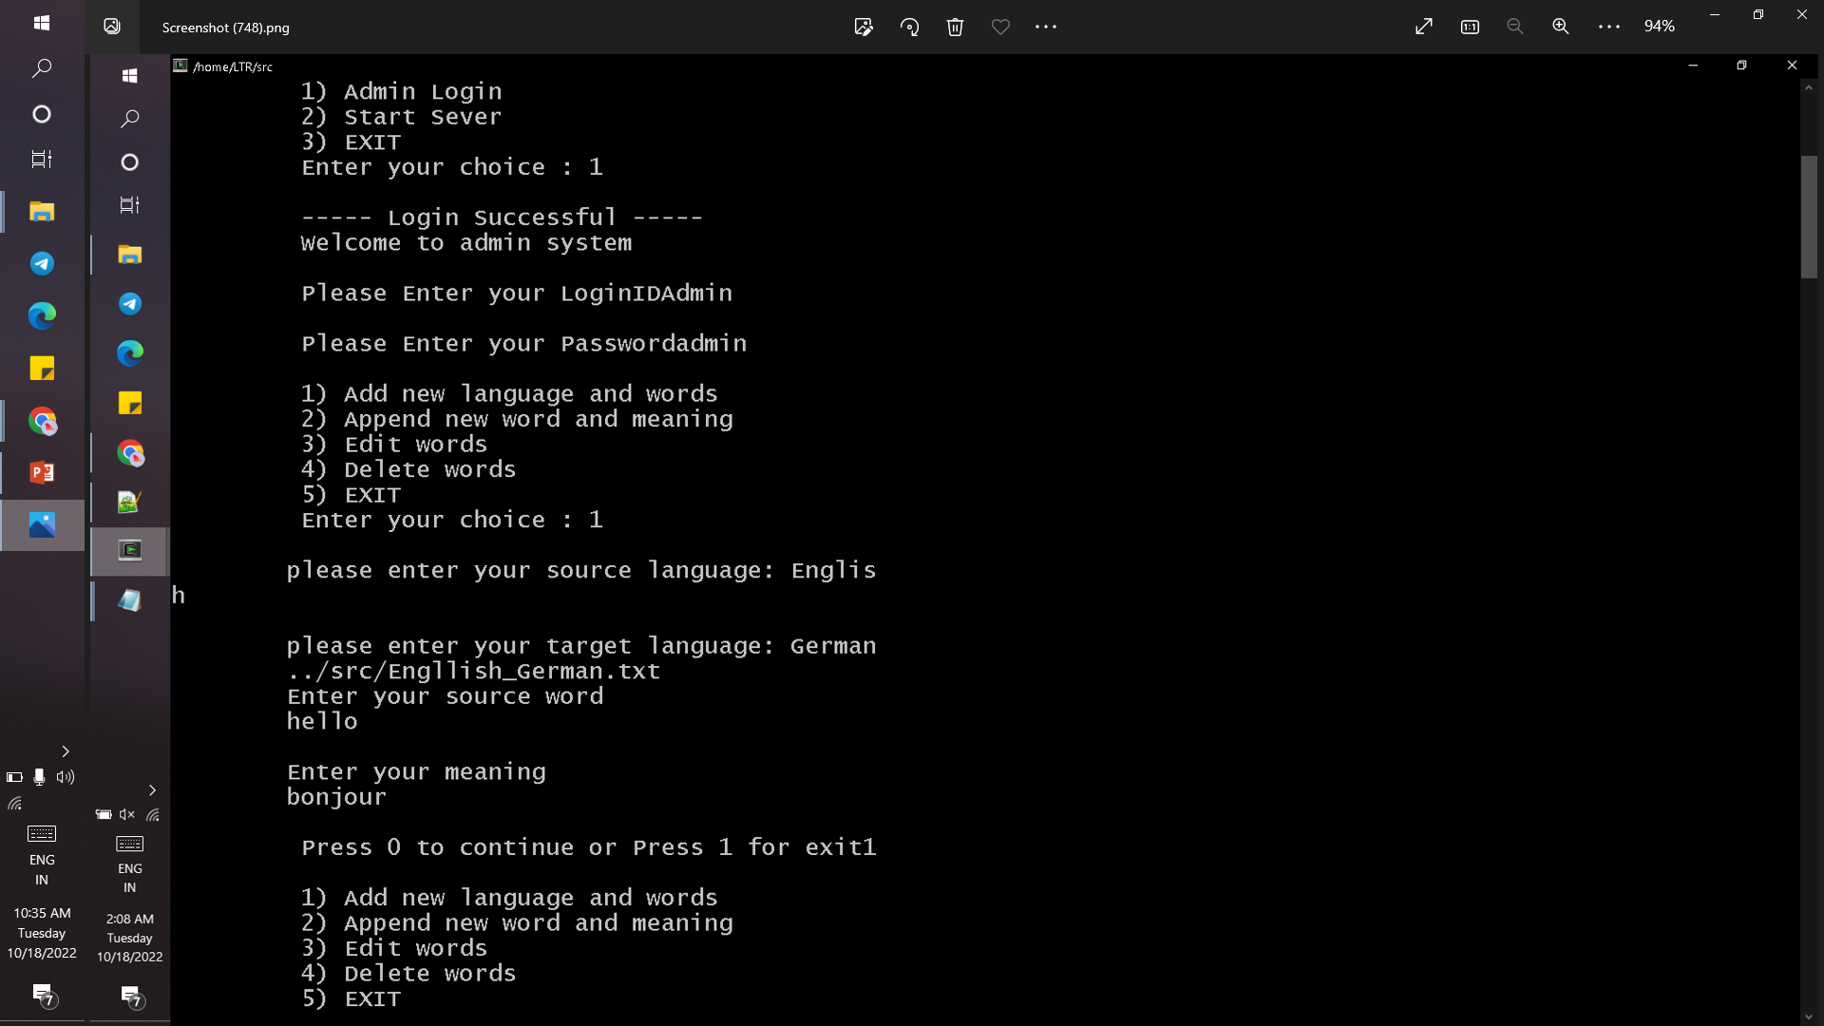

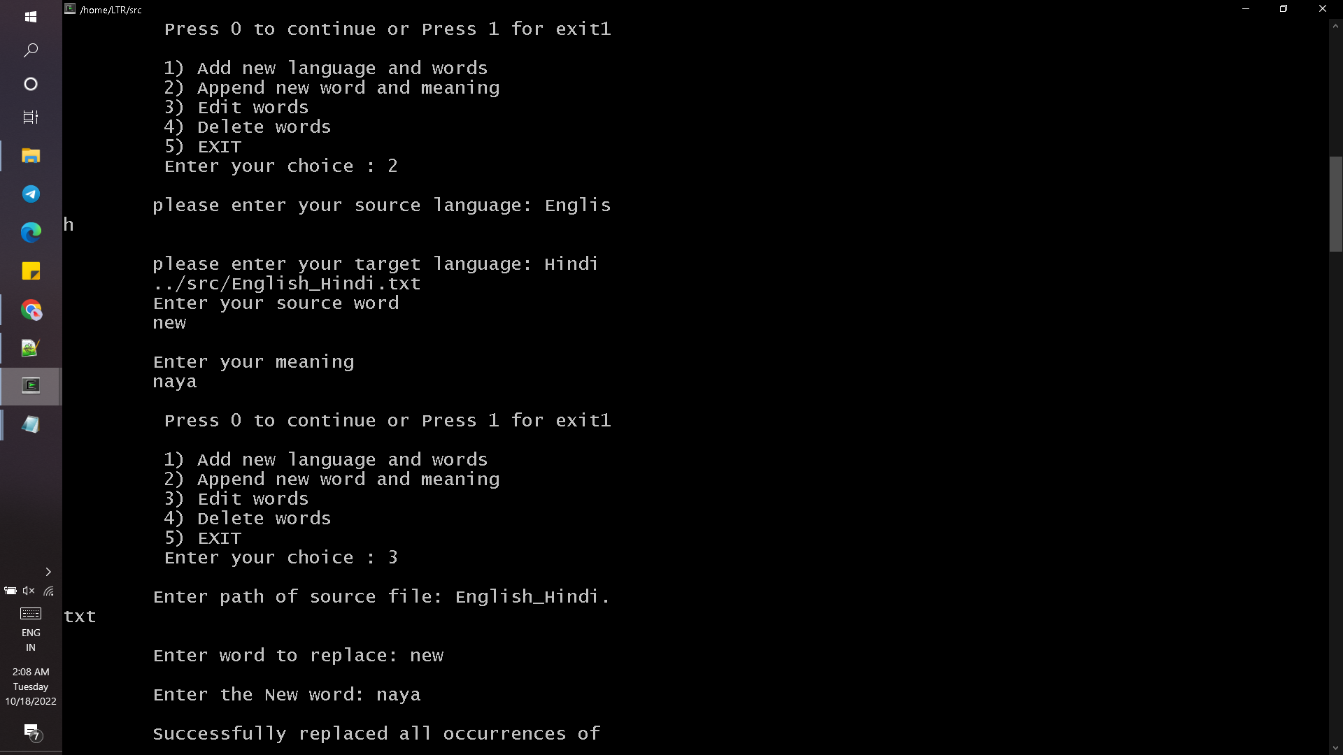

**IT_CASE 3 : Edit words**



**IT_CASE 4 : Delete words**

